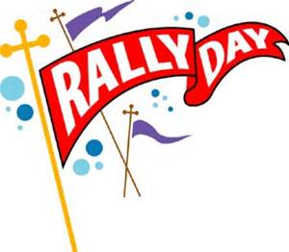
RALLY DAY SEPTEMBER 20, FOLLOWING WORSHIP
FRIENDS AND FAMILIES ARE WELCOMED!

Our Annual Rally Day barbeque and block party will immediately follow worship on September 20 from 12-3pm. Everyone is encouraged to bring a dish, hot dogs, hamburgers and beverages will be provided. Please bring a friend and enjoy an afternoon of fellowship and fun. Volunteers are also needed to set up and break down. Please contact Elsa Webb for further details. (718) 309 1165.

