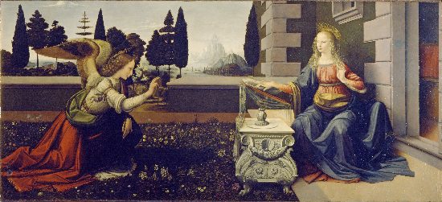
St. John’s Lutheran Church
Proudly Presents,

"A Festival of Nine Lessons and Carols"

Mr. Thomas Sax, Organist/Music Director
Sunday, December 11, 2016 at 10:30a.m.
216 Jewett Ave, (718) 761 1600

Come share in this special recalling
of the Christmas Story through
Scripture lessons and carols.
Music of the season by our Church’s Adult Choir
accompanied by Hand-bells, Violins, Flute and Organ

