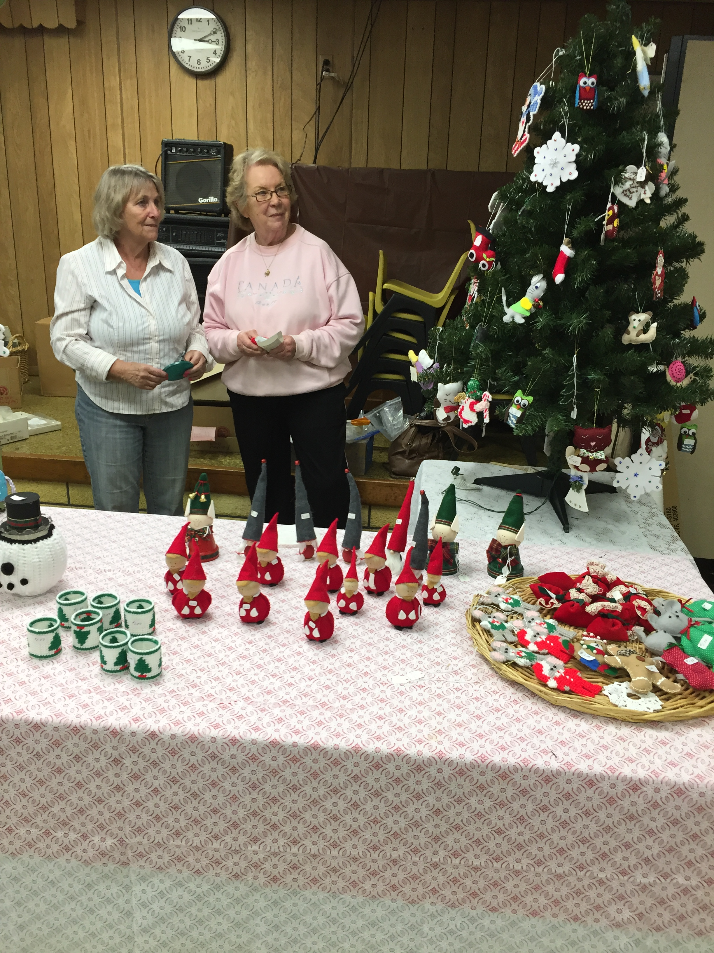  Saturday, November 18  St. John’s Lutheran Church’s Christmas Fair  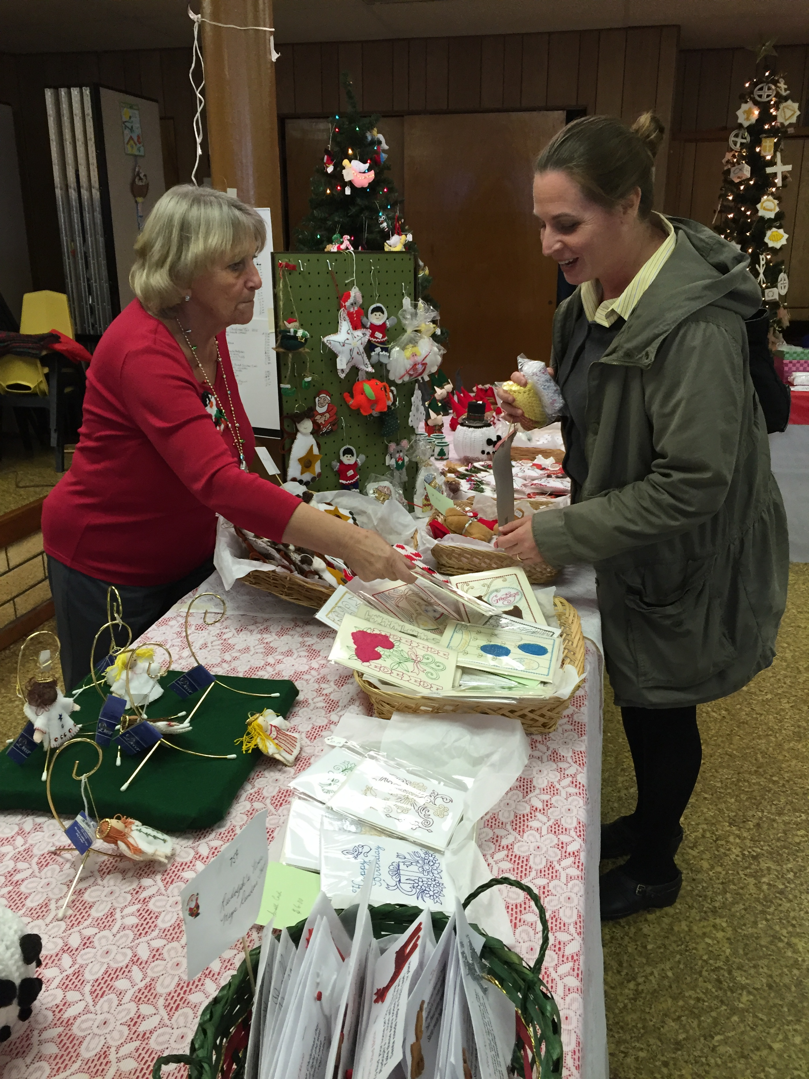 | Handmade Christmas Decorations,  Baked Goods  ────  Trash to  Treasure Table  ────  Sit down and enjoy lunch from 11-2pm  Sandwiches,  New England Clam Chowder and more.  ────  Free Admission!  ────  Everyone Welcomed!  Christmas Fair in  School’s Gym  663 Manor Road  718 761 1600  www.stjohnslutheransi.org  9:30 a.m. – 3:00pm

