2018 Thanksgiving Food Boxes
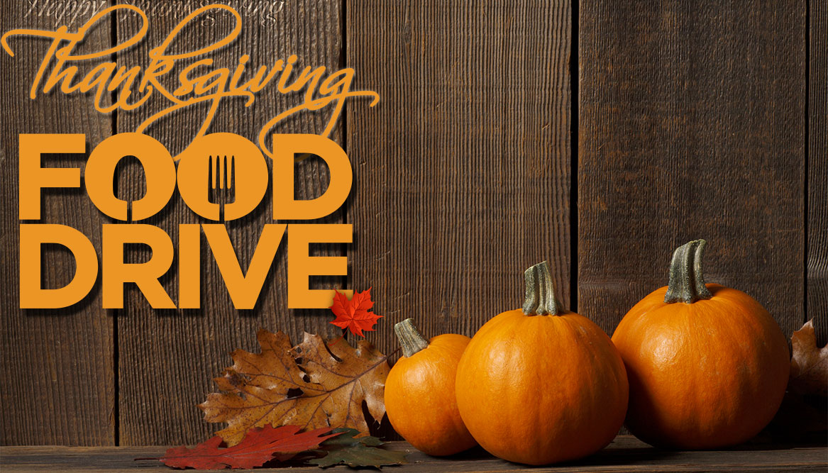
In preparation for the thanks – giving season the St. John’s Lutheran Church and School families will be donating food to help those in need. We are grateful for the help from the Rotary Club who has supplied the turkeys and various food items every year. Together we will be helping 14 families to enjoy a bountiful Thanksgiving meal, and more!
The food collection at the church will be on Sundays, October 28, November 4 and 11. Bags with food lists are available at the church, but you may bring your own bags or boxes with the food. Your generosity will be a blessing to many. Please call me at (718) 273 2644 with any questions.

Thank You!
Joan Mohlenhoff

