**EASTER PLANTS ORDER FORM 2025**

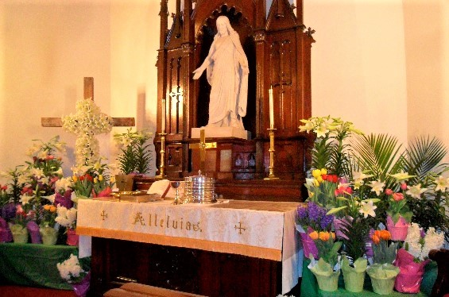

If you would like to order plants to decorate the church on Easter, you may do so by filling out this form and mailing it to the church office or placing it in the offering box along with your payment. The cost per plant is $15. Checks are payable to St. John’s Lutheran Church. Please write Easter plants in the memo on your check. **The deadline to order a plant(s) is Sunday, March 16, 2025**. At the conclusion of our Easter worship service please take your plant(s) home.

I wish to order ____ Plant(s) x $15 = **Total Enclosed** $ _______

**In loving memory of:**

________________________________________________________________________________________________________________________________________________________________________________________________________________________________________________________________________________________________________________________________________________________________________________________________________________________________________________________________________________________________________________________

**To commemorate an occasion or to honor someone:**

_____________________________________________________________________________________________________________________________________________________________________________________________

**Given by:**

_____________________________________________________________________________________________________________________________________________________________________________________________