**Worship Opportunities during**

**Lent and Holy Week**

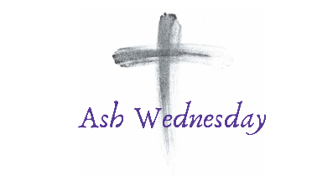

**March 5 - Ash Wednesday Vespers Service 6:30pm with Imposition of Ashes**

**Wednesdays - 6:30pm March 12, 19, 26,**

**April 2 and 9**

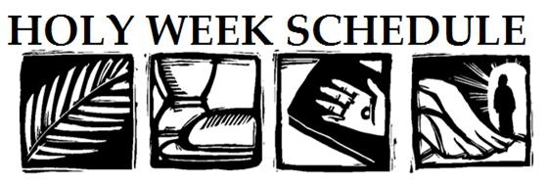

**Palm Sunday, April 13**

**10:30 a.m. Distribution of Palms**

**Divine Service with Holy Communion**

**April 17 - Maundy Thursday Divine Service with Holy Communion 6:30pm (Stripping of the Altar)**

**April 18 - Good Friday**

**2pm and 6:30pm**

**6:30pm Tenebrae Service**

**("Service of Darkness")**

**The Resurrection of Our Lord**

**Easter Sunday April 20**

**Divine Service 9:30 a.m. (Only)**

**Easter Breakfast 8:00-9:00 a.m.**