 

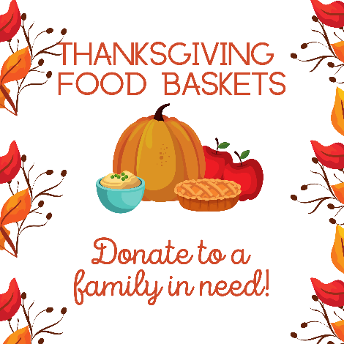

On behalf of the Board of Evangelism/Social Ministry I am writing to request assistance with the 2024 Thanksgiving Food Collection.

 Food may be dropped off on Sunday October 20, 27, November 3, 10, and 17, 2024. The last day for food collection will be on NOVEMBER 17. Distribution of the Thanksgiving Food Baskets will be on Saturday, November 23.

We welcome various types of canned food items such as soups, beans, pasta, fruits and vegetables; as well as boxed starch items such as rice, and instant potatoes.  We can also accept box cereals, cake mixes, and canned gravy. Low sodium food items are requested as some of our recipients have special diets.

Anyone who would rather make a monetary donation may do so by writing a check out to ***St. John’s Lutheran Church*** and **MUST** say **HUNGER FUND** in the check’s memo.

*If anyone is aware of a family that needs help, please contact me at 646-469-7891 and I will add them to our list.

Thank you for your thoughtfulness and continued support.

Sincerely,

Joy Hope Rouse

Chair of Board of Evangelism