Please DO NOT sit or MOVE the BIBLES that
are on the pews.

Only sit where there are hymnals in their holders.

Each pew alternates aisle window.
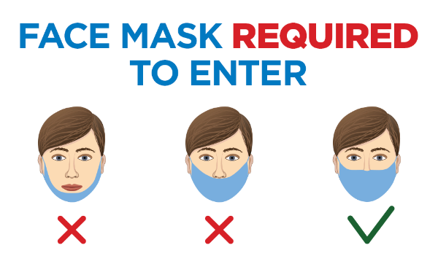
Please be considerate of your fellow parishioners and wear your face mask properly at all times.

